St.JOSEPH’S COLLEGE OF ENGINEERING, CHENNAI – 119.
St.JOSEPH’S INSTITUTE OF TECHNOLOGY,CHENNAI – 119.
ASSIGNMENT – II

UNIT – III MAGNETIC MATERIALS
PART – A
1. Define magnetic susceptibility and magnetic permeability.
Magnetic susceptibility : It is defined as the ratio between intensity of magnetization (I) and magnetic field intensity (H) χ_{m} = I / H
Magnetic Permeability : It is defined as the ratio between the magnetic flux density (B) and magnetic field intensity (H) µ = B / H
2. Define energy product of a magnetic material. Give its importance in the case of
permanent magnets.
The product of retentivity and coercivity is known as energy product. It gives the maximum energy stored in the magnets which helps in distinguishing a weak and strong magnet.
3. A paramagnetic material has a magnetic field intensity of 10⁴ ampere/m. If the
susceptibility of the material at room temperature is 3.7x10⁻³, calculate the
magnetization of the material.
χ = I / H → I = χ H = 3.7x10⁻³ x 10⁴ = 37 Am⁻¹
4. Define retentivity and coercivity.
Remenance is the property of the magnetic material by which it retains some magnetisation when the
magnetising field is reduced to zero.It is expressed in terms of weber / m2.
Coercivity is the property of the magnetic material by which it requires a demagnetising force to
destroy the residual magnetism in it. It is expressed in terms of ampere turn /m.
5. Define Bohr Magneton
The orbital magnetic moment and the spin magnetic moment of an electron in an atom can be expressed interms of atomic unit of magnetic moment called Bohr magneton.
1 Bohr magneton = 9.2 x 10⁻²⁴ Am².
6. Give any two applications of ferrites.
- Ferrites are used in audio and video transformers
- Used in computer and data processing circuits.
7. What is meant by Meissner effect?
When a material is cooled below its transition temperature the material becomes a perfect diamagnet.The magnetic flux originally present in the material gets ejected out of a superconductor.
8. Define transition temperature with example.
The temperature at which a normal material changes into a superconductor is called transition temperature.

9. Prove that superconductor is a diamagnet.
B = µ₀ (I+H) : When B = 0, we get 0 = µ₀ (I+H) : Since µ₀ ≠ 0, we can write I + H = 0;
or I = -H or I/H = -1 = χ.
10.Calculate the critical current which can flow through a long thin superconducting wire
of aluminium of diameter10⁻³ m. The critical magnetic field for aluminium is 7.9 x 10³ A/m.
I_{c} = 2πrH_{c} = 2x3.14x10⁻³/2x7.9x10³ = 24.81 Amp
PART – B
1. i) What is ferromagnetism?
Ferromagnetic materials possess permanent dipole moment and undergoes saturation
magnetization.

ii) Discuss the domain structure in ferro magnetic material. 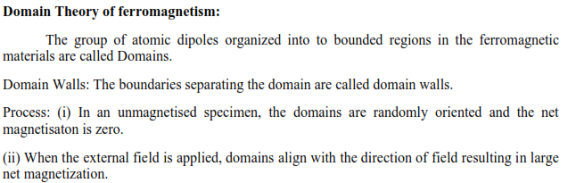

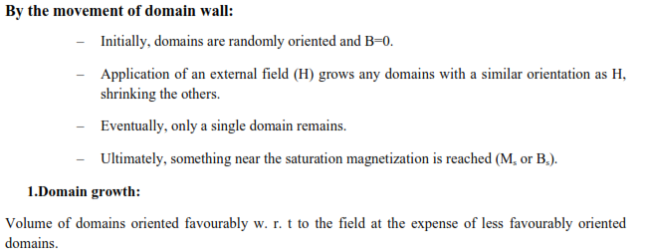
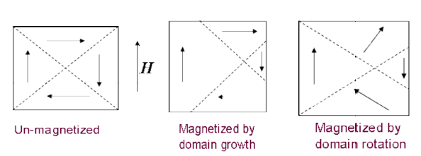
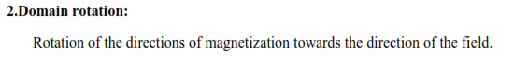
iii) Explain the different types of energy involved in the formation of domain.
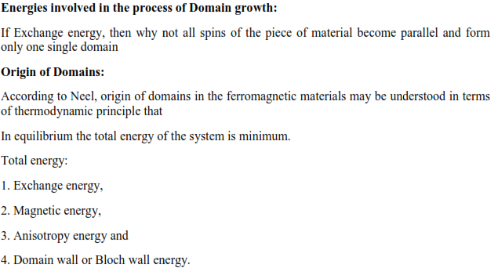
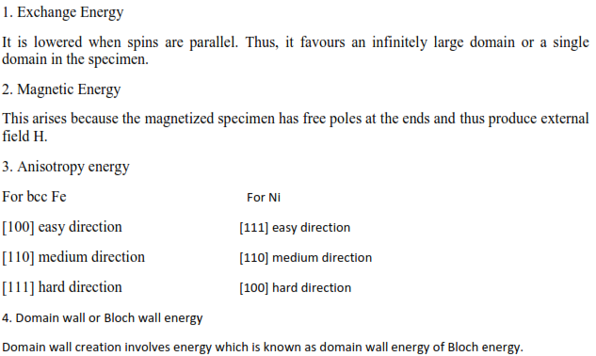
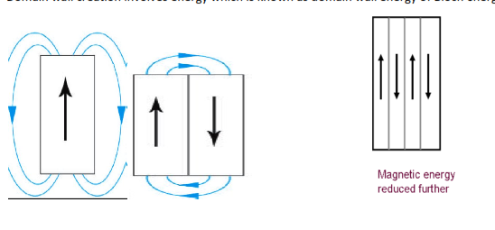
2. Explain the phenomenon of hysteresis on the basis of domain theory in ferromagnetism.
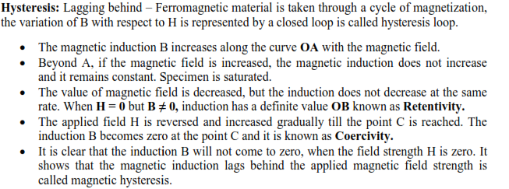
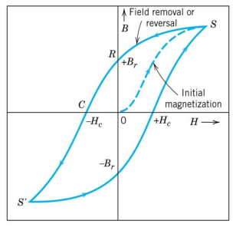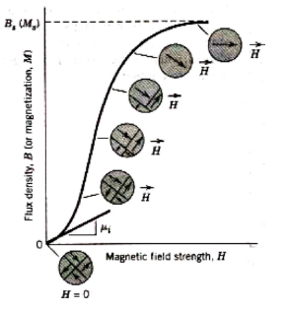
3. Classify the magnetic materials on the basis of their spin.
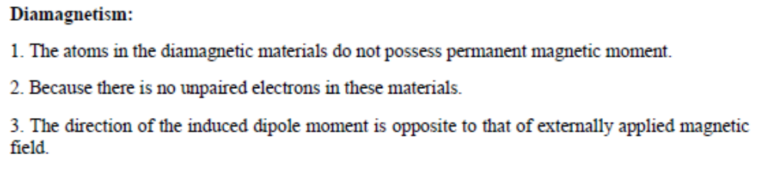
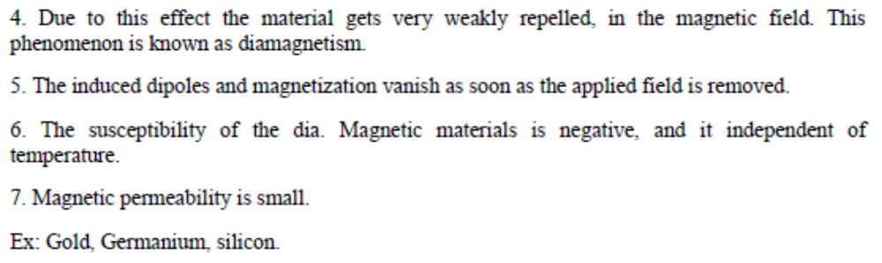
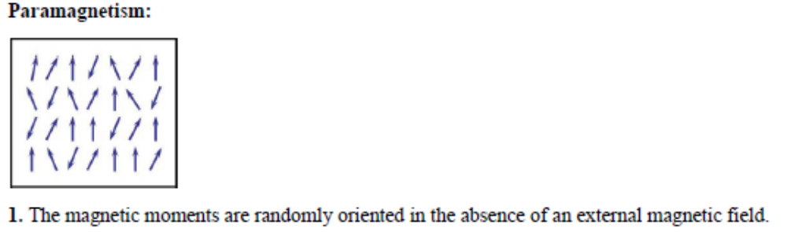
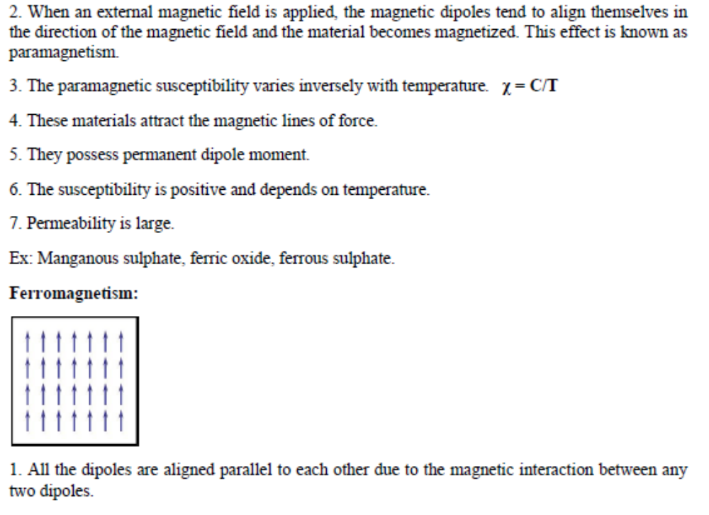
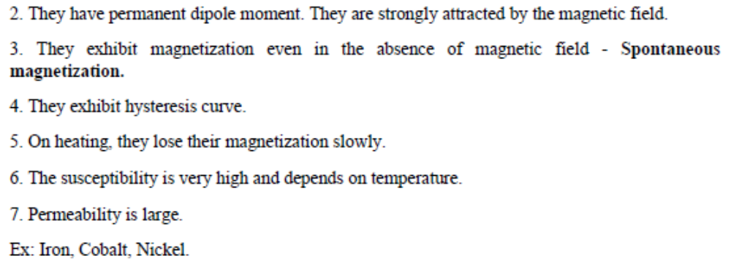
4. Briefly explain the structure and applications of ferrites.
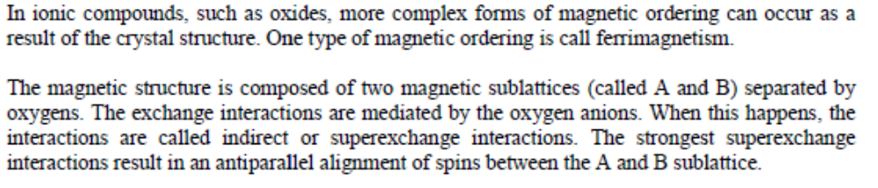
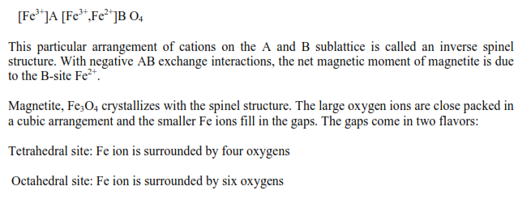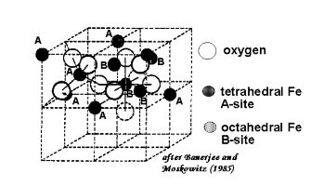

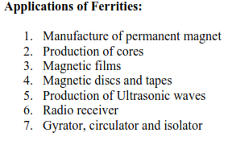
5. i) Distinguish between hard and soft magnetic materials.
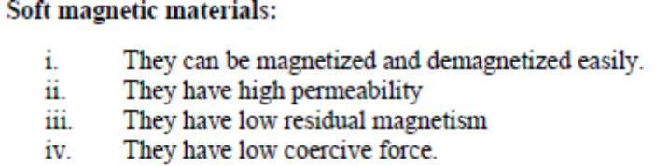
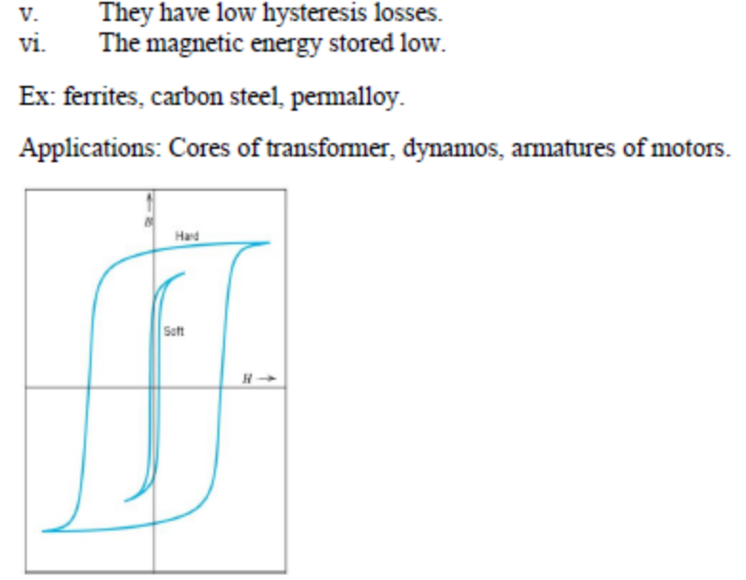
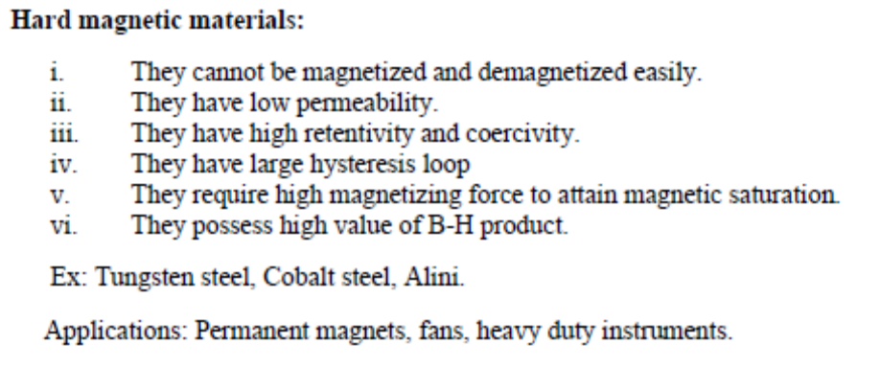
ii) In a magnetic material, the field strength is found to be 10⁶ A/m. If the magnetic susceptibility is 0.5 x10⁻⁵, calculate the intensity of magnetization and flux density in the material.
χ = I / H → I = χ H = 0.5x10⁻⁵ x 10⁶ = 50 Am⁻¹
B =µ_{o} (H+I) = 4x3.14x10⁻⁷ (10⁶ +50) = 1.256Wb/m²

6. Explain the superconducting phenomena with its properties.
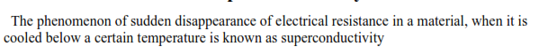
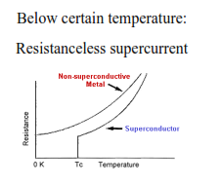

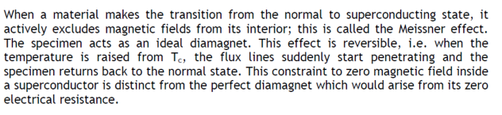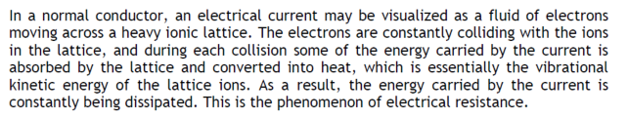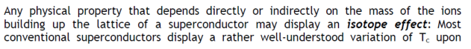
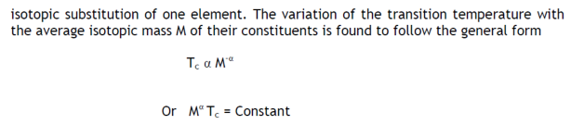

7. i) What are high temperature superconductors? Give examples.
High-temperature superconductors (abbreviated high-T_{c} or HTS) are materials that behave as superconductors at unusually high temperatures. HTS have been observed with transition temperatures as high as 138 K
ii) Explain its structure and give the importance of oxygen content in YBa₂Cu₃O₇
The first superconductor found with T_{c} > 77 K is yttrium barium copper oxide (YBa₂Cu₃O_{7-x}); the proportions of the 3 different metals in the YBa₂Cu₃O₇ superconductor are in the mole ratio of 1 to 2 to 3 for yttrium to barium to copper, respectively. Thus, this particular superconductor is often referred to as the 123 superconductor.The unit cell of YBa₂Cu₃O₇ consists of three pseudocubic elementary perovskite unit cells. Each perovskite unit cell contains a Y or Ba atom at the center:
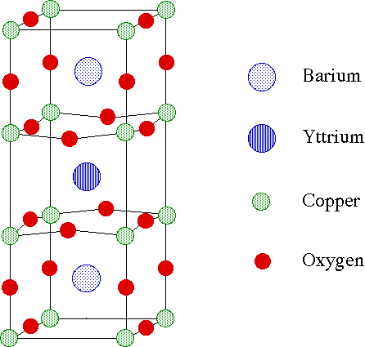
8. i) Discuss type I and type II superconductors.
S.No | Type – I | Type – II
1 | The material loses magnetisation suddenly | The material loses magnetisation gradually
2 | There is only one critical magnetic field | There are two critical magnetic fields, lower and upper.
3 | No mixed state exists. | Mixed state is present.
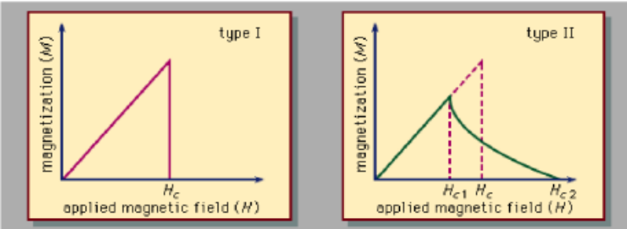
ii) Explain the BCS theory of superconductors
BCS theory is the first microscopic theory of superconductivity since its discovery in 1911. The theory describes superconductivity as a microscopic effect caused by a condensation of Cooper pairs into a boson-like state. The theory is also used in nuclear physics to describe the pairing interaction between nucleons in an atomic nucleus. It was proposed by John Bardeen, Leon Neil Cooper, and John Robert Schrieffer ("BCS") in 1957; they received the Nobel prize in physics for this theory in 1972. BCS derived several important theoretical predictions that are independent of the details of the interaction, since the quantitative predictions mentioned below hold for any sufficiently weak attraction between the electrons and this last condition is fulfilled for many low temperature superconductors - the so-called weak-coupling case. These have been confirmed in numerous experiments.The electrons are bound into Cooper pairs, and these pairs are correlated due to the Pauli exclusion principle for the electrons, from which they are constructed. Therefore, in order to break a pair, one has to change energies of all other pairs. This means there is an energy gap for single-particle excitation, unlike in the normal metal (where the state of an electron can be changed by adding an arbitrarily small amount of energy). This energy gap is highest at low temperatures but vanishes at the transition temperature when superconductivity ceases to exist. The BCS theory gives an expression that shows how the gap grows with the strength of the attractive interaction and the (normal phase) single particle density of states at the Fermi level. Furthermore, it describes how the density of states is changed on entering the superconducting state, where there are no electronic states any more at the Fermi level. The energy gap is most directly observed in tunneling experiments and in reflection of microwaves from superconductors.
9. Based on the properties of superconductors, describe the various application of superconductors.
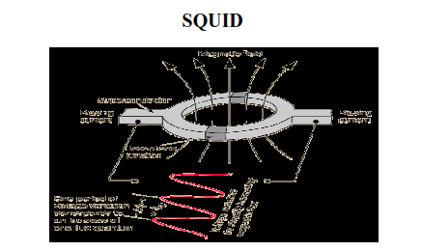
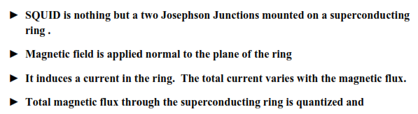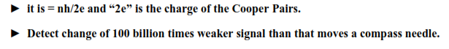
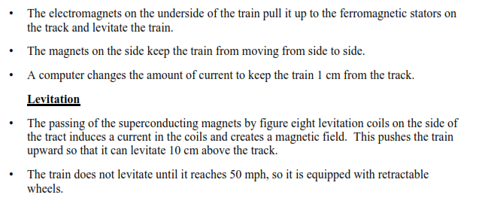
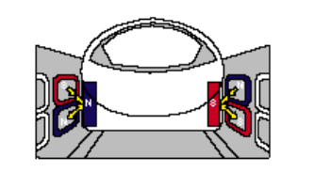

10. Distinguish between ferro, ferri and anti ferro magnetic materials. Give examples for each.
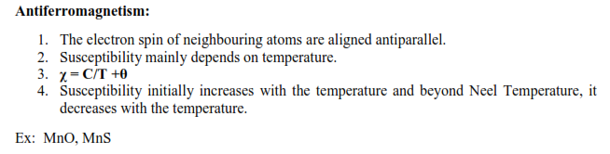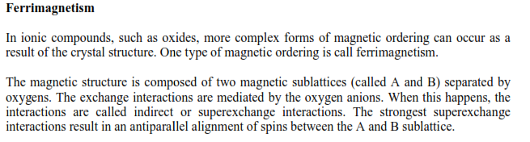
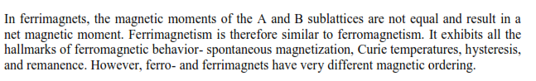
UNIT – IV DIELECTRIC MATERIALS
PART – A
1. Define dielectric constant
Dielectric constant is the measure of the polarization produced in the material. It is the ratio
between the absolute permittivity and the permittivity of free space.
2. Mention any two liquid insulating materials.
- Synthetic oils are used as coolant and in high voltage transformers.
- Minral oils are used as transformer oils.
3. Calculate the electronic polarisability of argon atom given ξ_{r}=1.0024 at NTP and
N=2.7x10²⁵atoms/m³.
α_{e} =ε_{o}(ε_{r} -1)/ N = 8.85x10⁻¹²)(1.0024-1)/ 2.7x10²⁵ = 7.9 x 10⁻⁴⁰ Fm²
4. What are the polar and non polar dielectrics?
The molecules having permanent dipoles are called as polar dielectrics and those do not have permanent dipole moment are called as non – polar dielectrics.
5. Find the dielectric constant of a material which when inserted in parallel capacitor of
area 10 mm x 10 mm and distance of separation of 2 mm gives a capacitance of 10⁻⁹ F.
C = ε_{r}ε_{o}A / d : ε_{r =} Cd/ ε_{o}A = 10⁻⁹x2x10⁻³/8.854x10⁻¹²x10²x10⁻⁶ = 2259
6. What are the ways in which dielectric breakdown can be minimized?
(i) It should posses high dielectric strength and low dielectric loss.
(ii) It should have less density and thermal expansion.
(iii) It should be pure.
(iv) It should have high resistivity and sufficient mechanical Strength.
7. What are active & passive dielectrics?
Active dielectrics: It can easily adopt itself to store the electrical energy in it. Exs: Piezo electrics, Ferro electrics .It is used in production of ultrasonics
Passive dielectrics: Dielectrics which restricts the flow of electrical energy in it . Exs: Glass, Mica, Plastics.It is used in production of sheets, pipes etc.
8. Prove χ _{e} = ξ_{r}-1
We know the polarization 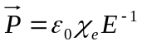
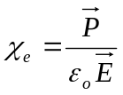 ………... (1)
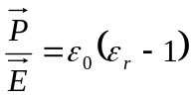 ……….. (2)
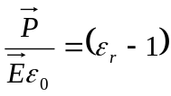
Comparing equation 1 and 2 we get
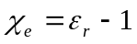 Thus proved
9. Define dielectric breakdown and dielectric strength.
When external field applied to a dielectric material is greater than the critical field, the dielectric loses its insulating property and becomes conducting. Therefore a large current flows through the material.It is the minimum strength required per unit thickness of the dielectric material to produce dielectric breakdown
10. What is space-charge polarization.
When a dielectric is placed in an electric field diffusion of ions take place along the field direction, giving rise to redistribution of charges in the dielectrics and this phenomenon is known as space-charge polarization

PART – B
- i) What is polarization?
The process of producing electrical dipoles inside the dielectric by the application of an external electric field is called polarization in dielectrics.
ii) Explain the various types of polarization mechanisms involved in dielectric materials.
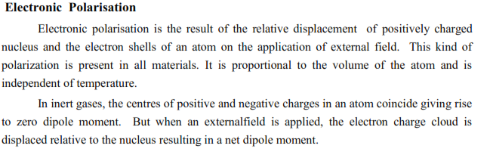
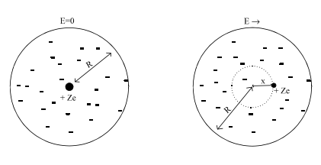
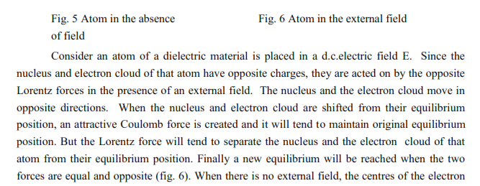

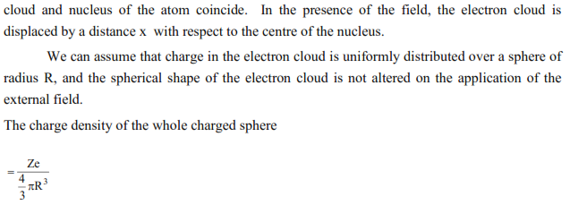
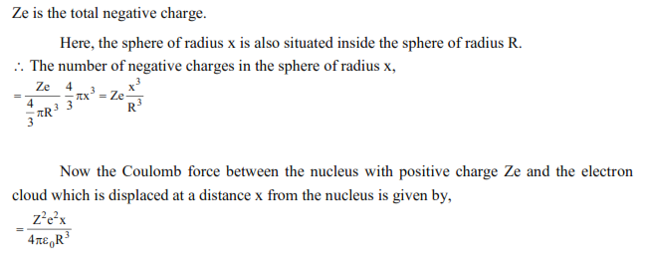
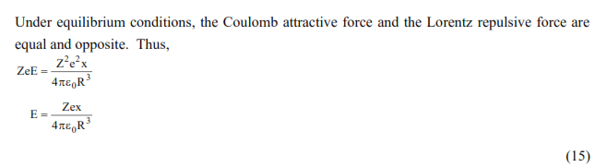
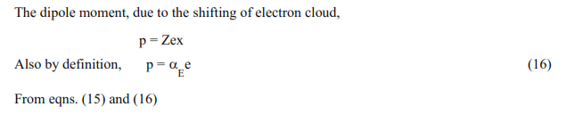

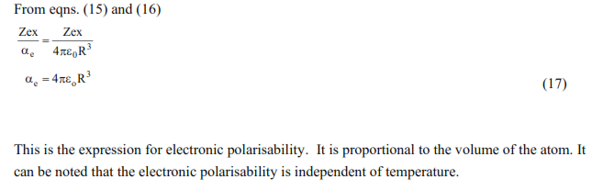
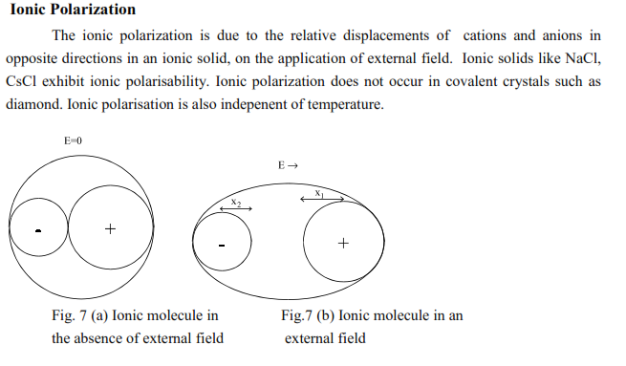
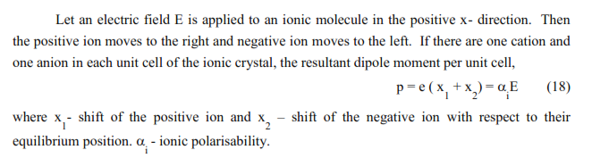
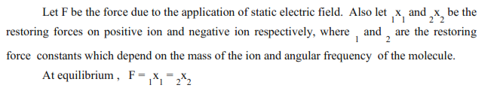
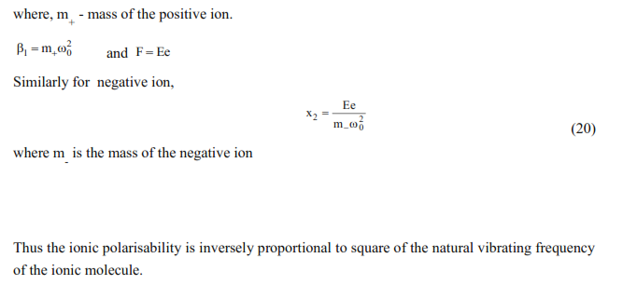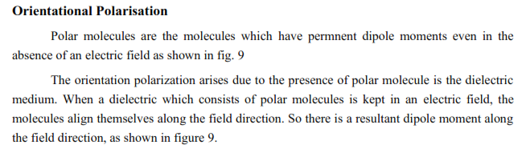
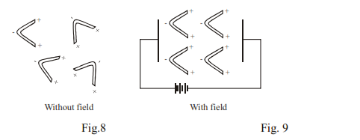
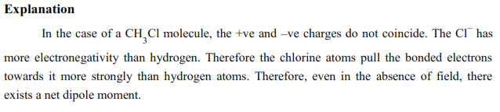

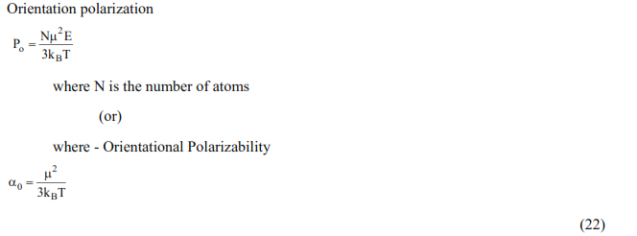
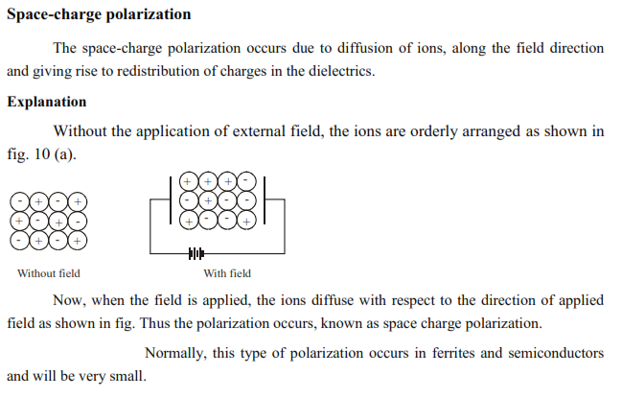
- i) What is meant by internal field?
When a dielectric is kept in an external electric field (E), two fields are exerted due to (i) external field and (ii) dipole moment created. These long ranges of coulomb forces which are created due to the dipoles are called internal field (or) local field in dielectric.
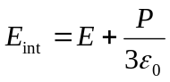

ii) Deduce an expression for internal field and hence obtain Clausius-Mosotti equation.

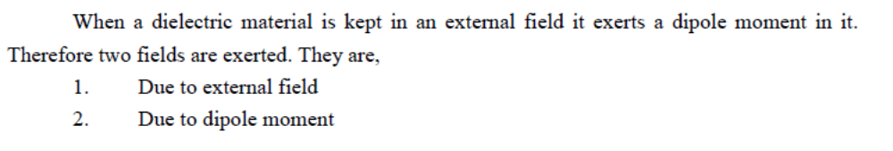
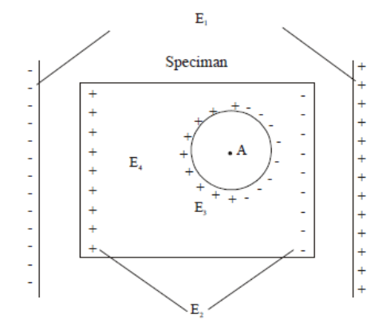
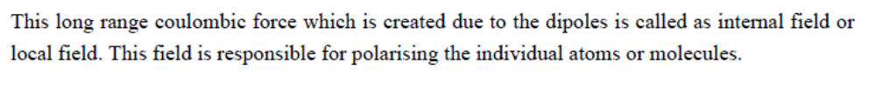
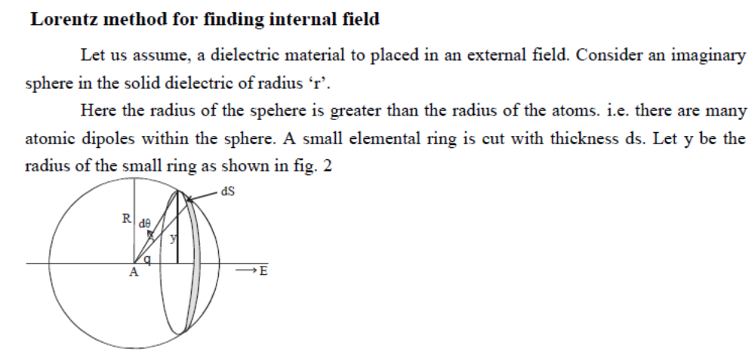
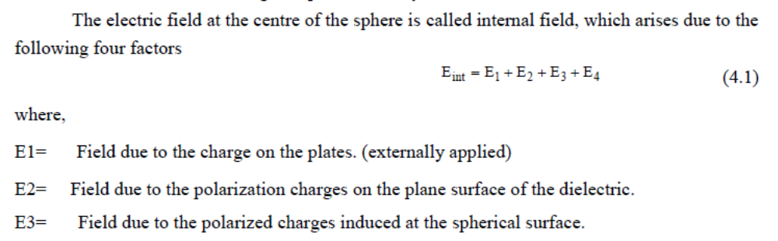
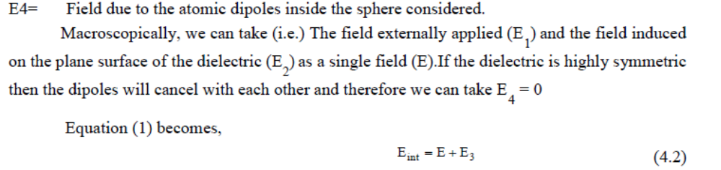
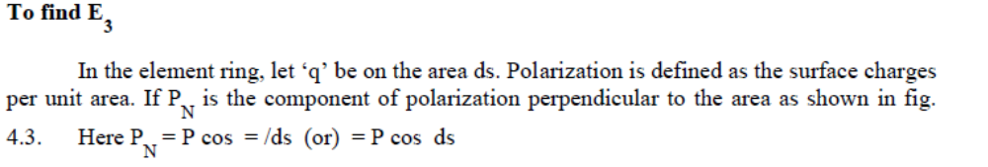
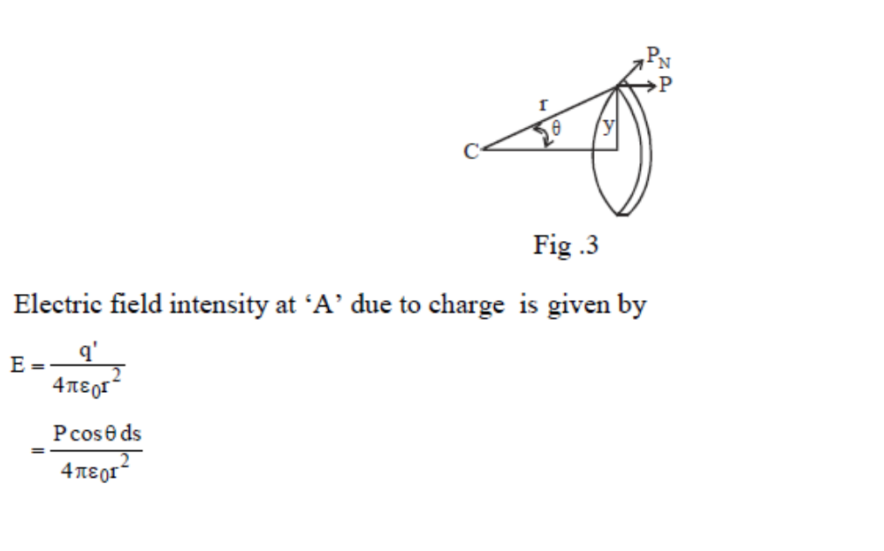
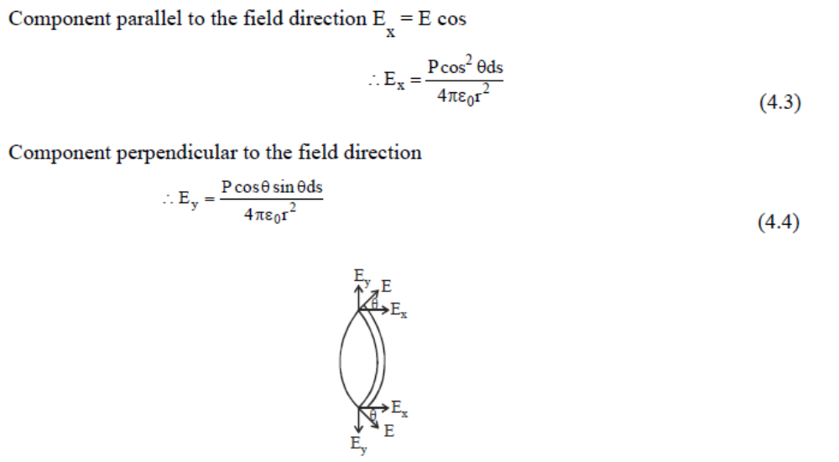
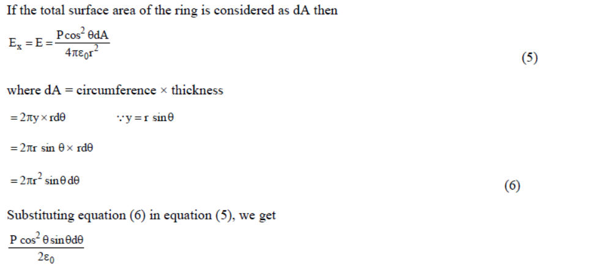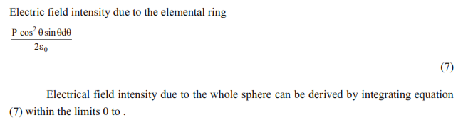
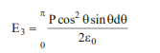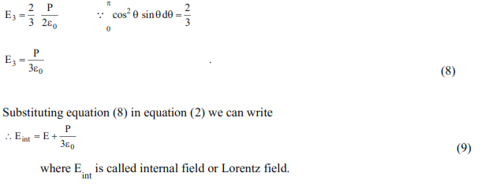
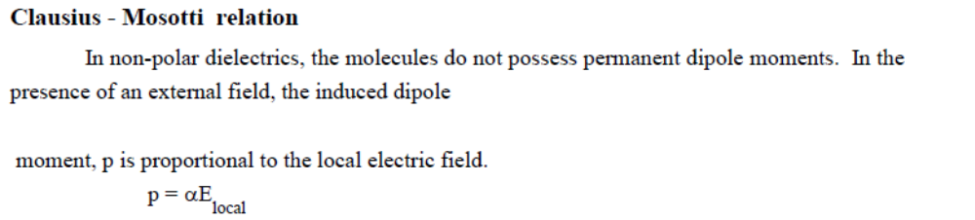
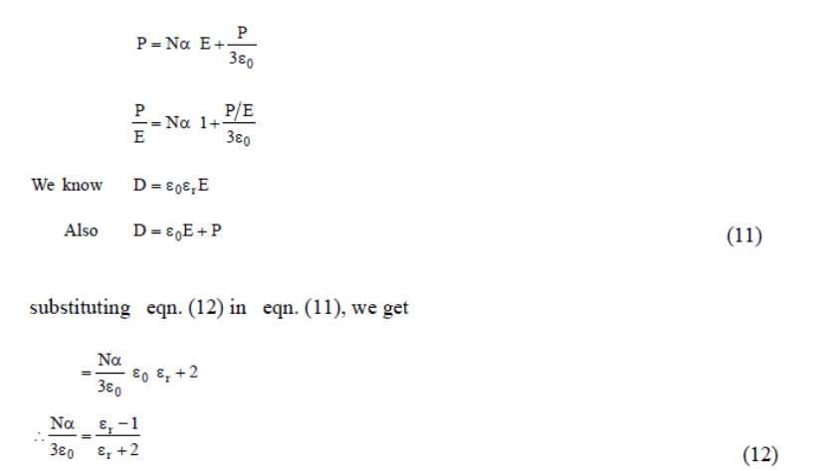
- i) What do you mean by dielectric loss?
When a dielectric material is subjected to electric field, the electrical energy is absorbed by the dielectric and certain amount of electrical energy is dissipated in the form of heat energy. This is the loss in the energy in the form of heat is called as dielectric loss.

ii) Explain the phenomenon of dielectric loss in detail.
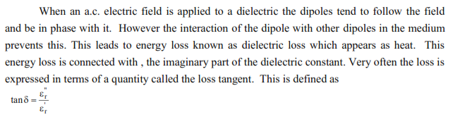
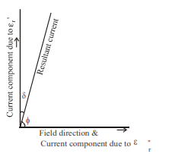
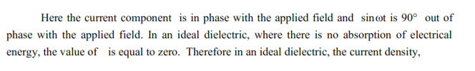
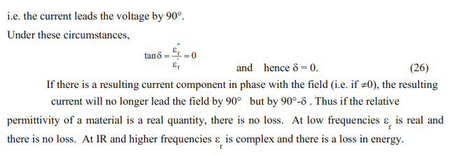

iii) Describe the frequency and temperature dependence of polarization.

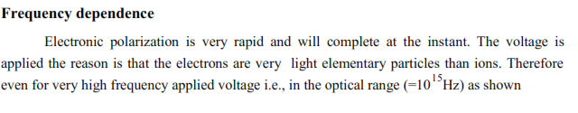
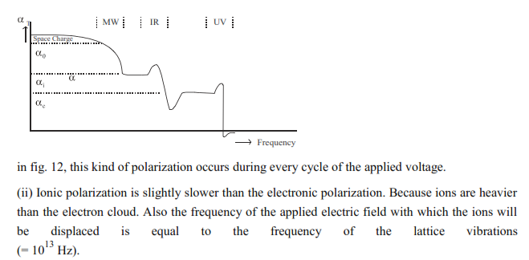
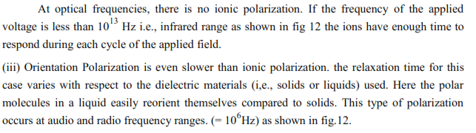
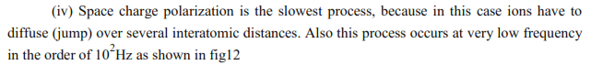
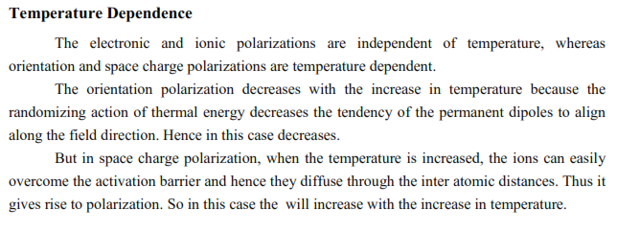

- i) Explain in detail various types of dielectric breakdown mechanisms.
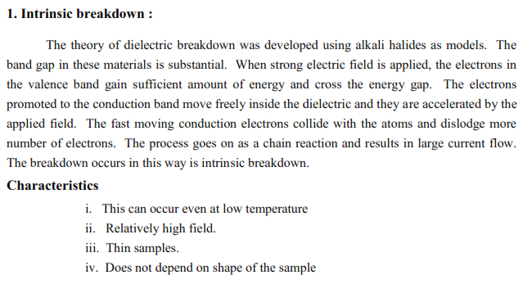
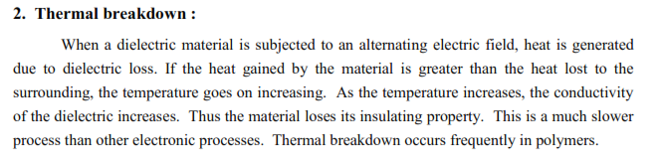
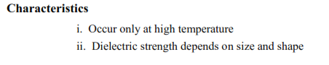

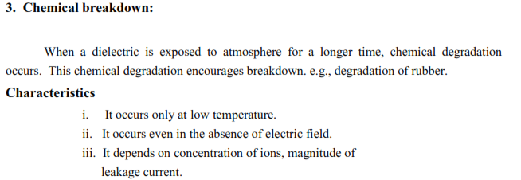

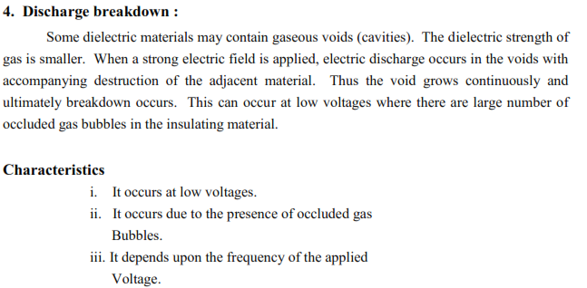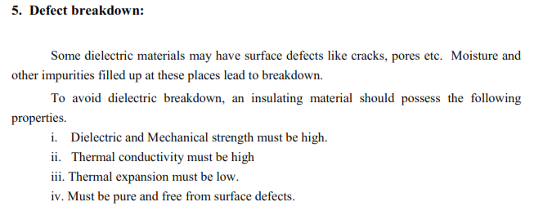

ii) Discuss the remedies of dielectric breakdown.
- It should have high resistivity
- It must possess high dielectric strength
- It should have sufficient mechanical strength.

- i) What is ferro electricity?
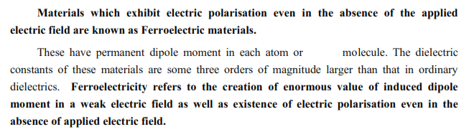
ii) Give examples for ferro electric materials.
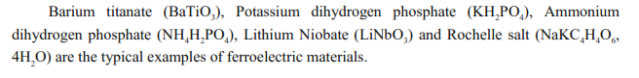
iii) Write the properties and applications of ferro electric material.
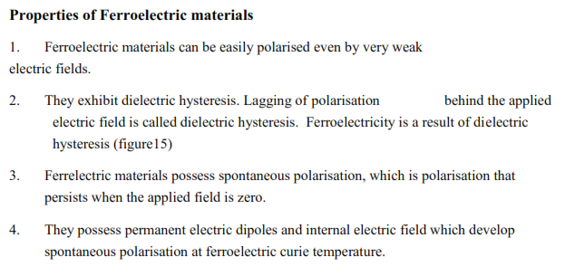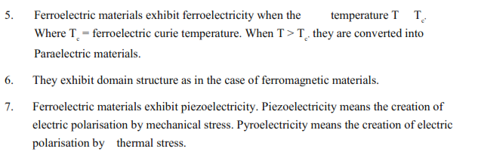
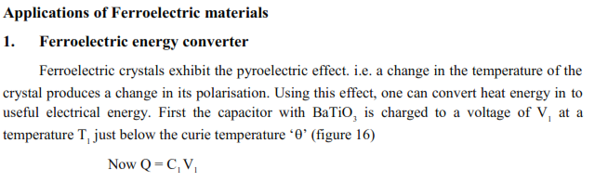
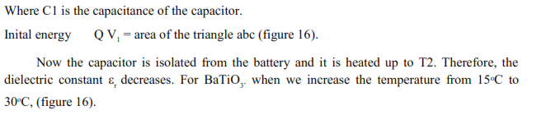
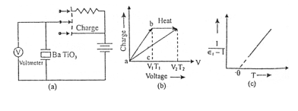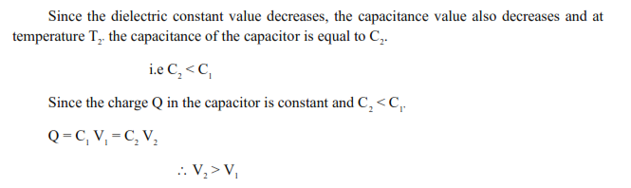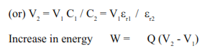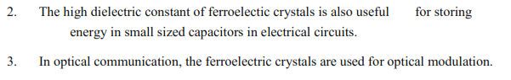
- i) Explain the uses of dielectric materials in capacitors and transformers.
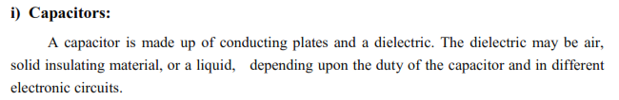
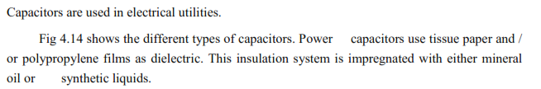
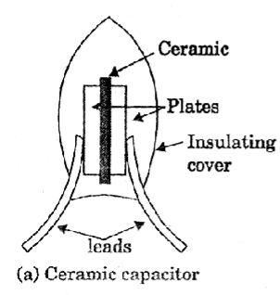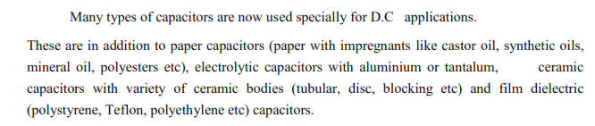
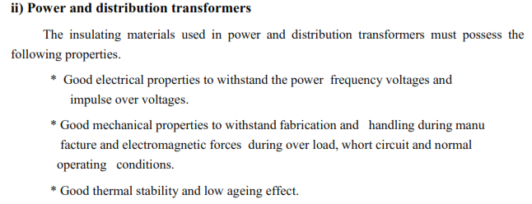
ii) Draw a graph for the variation of power loss with frequency.
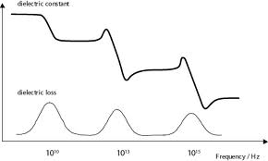
UNIT V - ADVANCED ENGINEERING MATERIALS
PART A
1. What are the types of metallic glasses? Mention few examples.
Types of metallic glasses
Metal- metalloid metallic glasses, Eg: Fe, Co, Ni: Bi, Si, P
Metal-metal metallic glasses Eg: Ni, Nb
2. What is the advantage of using metallic glasses as a transformer core material?
Metallic glasses possess low magnetic losses, high permeability, high saturation magnetization and extreme mechanical hardness. Therefore they are used as transformer core materials.
3. What is glass transition temperature?
The temperature at which the transition from liquid to solid occurs is known as glass transition temperature.
4. Mention different forms of nanomaterials.
Nanorods, nanodots, nanowires, nanobuds, nano composites, Carbon nanotubes and Fullerenes
5. Define pseudo elasticity.
In some types of shape memory alloys, change in shape occurs without any change in temperature. This change in shape is stress induced and is called pseudo elasticity.
6. Name few non-linear optical phenomena.
Higher harmonic generation, Optical mixing, Optical phase conjugation and Soliton
7. What are non-linear materials? Give any two examples.
The materials in which optical properties depend on the intensity of light are called non-linear optical materials. Eg: Lithium niobate, Lithium Tantalate, Barium sodium niobate
8. What are biomaterials?
The materials which are used for structural applications in the field of medicine are known as biomaterials. These materials are used to make devices to replace damaged or diseased body parts in human and animal bodies.
9. What are the types of biomaterials? Mention few biomaterials and their applications.
- Metals & alloys biomaterials
- Ceramic biomaterials
- Polymer biomaterials
- Composite biomaterials
a) Stainless steel is a predominant alloy widely used in implant and orthopaedic applications
b) Protosal from cast alloy of Co-Cr-Mo is used to make stem and head of implant hip endoprosthesis.

10. What is Kerr effect?
The Kerr effect is a phenomenon in which the refractive index of a material changes because of an applied electrical field, and the change in the refractive index is proportional to the square of the applied electric field. The Kerr effect is also known as the quadratic electro-optic effect (QEO effect).
UNIT V - ADVANCED ENGINEERING MATERIALS
PART B
- What are nano phase materials? Explain their properties
Nanophase materials are newly developed materials with grain size at the nanometre range i.e. in the order of 1-100 nm. The particle size in nanomaterials is 1 nm. They are simply called as nanomaterials. They exist in different forms like nanodots, nanorods, nanoparticles and nanotubes etc.
Properties of nanophase particles
a) Mechanical properties
- In nanophase materials, the elastic strength is low however; its plastic behavior is high.
- In some nanophase materials, it is noted that there is decrease in hardness when the grain size is less than 10 nm.
- Higher hardness and mechanical strength when grain size reduces to nano range.
- It has very high ductility and superplastic behavior at low temperatures.
b) Magnetic properties
Nanoparticles of non-magnetic solids also exhibit new type of magnetic properties.
- Bulk magnetic moment increases with decrease in coordination number. This means that small particles are more magnetic then the bulk material.
- The nanomaterials show variation in their magnetic property when they change from bulk state to cluster (nanoparticles) state.
- Non-magnetic materials become magnetic when the cluster size reduces to 80 atoms.
c) Chemical properties
The large surface to volume ratio, the variations in geometry and the electronic structure have a strong effect on catalytic properties. The reactivity of small clusters has been found to vary by higher orders of magnitude when the cluster size is changed by only a few atoms.
d) Variation of physical parameters with geometry
Starting from the bulk, the first effect of reducing the particle size is to create more surface sites. This in turn changes surface pressure and Interparticle spacing.
i) Interparticle spacing decreases with decrease in grain size for metal clusters. For example in copper, it decreases from 2.52 to 2.23 Å. The change in interparticle spacing and large surface to volume ratio in particles has a combined effect on material properties. Therefore, the nanophase materials have very high strength and super hardness
.
ii) Melting point reduces with decrease in cluster size
iii) Ionization potential changes with cluster size of the nanograins
iv) The large surface to volume ratio, the variations in geometry and the electronic structure have a strong effect on catalytic properties. The reactivity of small clusters has been found to vary by higher orders of magnitude when the cluster size is changed by only a few atoms.

2. Give the concept, properties and applications of metallic glasses.
Metallic glasses were discovered in 1970. Metals are solids with crystalline property, malleability, ductility etc. Glasses are amorphous materials which are transparent and brittle in nature. Metallic glasses are the newly developed engineering materials which share the properties of both metals and glasses. They have high strength, good magnetic properties and better corrosion resistance.
Ex: Alloys of Fe, Ni, Al and Cu mixed with metalloids such as Si, Ge, As and C.
Properties
- They do not have any crystal defects
- They have tetrahedral close packed structure
- They have high elasticity
- They are highly ductile
- Electrical resistivity is high and it does not vary much with temperature.
- Due to high resistivity, the eddy current loss is very small.
- They possess low magnetic losses, high permeability, high saturation magnetization and extreme mechanical hardness.
- They can act as catalyst

Applications
- They are used as reinforcing elements in concrete, plastic or rubber.
- They are used to make razor blades and different kinds of springs.
- They are used to construct large fly wheels for energy storage.
- They are used in transformers and magnetic shields since they possess low magnetic losses, high permeability, high saturation magnetization and extreme mechanical hardness.
- Used to produce high magnetic fields and magnetic levitation effect
- Used in preparing containers for nuclear waste disposal and magnets for fusion reactors
- Ideal materials for cutting tools and making surgical instruments

3. How are metallic glasses prepared? Explain how the melt spinner device can be used to produce metallic glass.
Metallic glasses are prepared based on the principle of rapid cooling technique called quenching. Metals are taken to glassy state by increasing the rate of cooling [2 x 10⁶ °C/second] and hence atoms won’t be able to arrange orderly. This results in amorphous state leading to a new type of material.

Melt spinning system
Principle
The cooled molten alloys are fed into highly conducting massive rollers at high speeds to give ribbons of metallic glasses.
Experimental setup
A melt spinner consists of refractory tube with fine nozzle and induction heater coil, spinning copper disc. This disc is rotated at a high speed to generate a high velocity of more than ∼ 50 ms⁻¹. The alloy is melted by induction heating under inert helium or argon atmosphere. Ejection rate can be increased by increasing the pressure inside the refractory tube. A properly superheated molten alloy is ejected under pressure through the nozzle onto the spinning disc. The dynamic melt puddle impinging on the moving substrate is solidified and it is thrown out of the wheel by centrifugal force after travelling with it over a short distance. Thus, a continuous ribbon is obtained due to rapid quenching and it is wound on a spool.
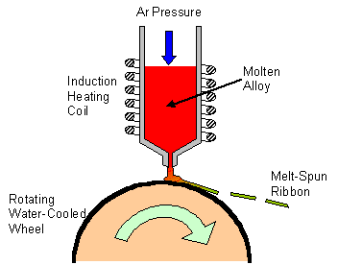

4. What are shape memory alloys? Explain the characteristics and applications of SMAs.
Shape memory alloys (SMA) are smart/intelligent materials which show the ability to return to their original shape or size when they are subjected to appropriate thermal procedure. The range of temperature at which SMA switches back to its original shape is called transformation temperature.
Phases of SMA
Martensite and Austenite are the two solid phases which occur in SMA as shown in Fig.
- Martensite is relatively soft and it is easily deformable phase which exists at low temperature (monoclinic).
- Austenite – is a phase that occurs at high temperature having a crystal structure and high degree of symmetry (cubic).
- The mechanism involved in SMA is reversible (austenite to martensite and vice versa).

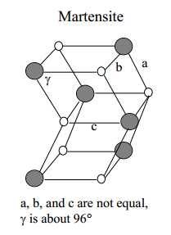
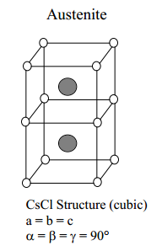

Characteristics of SMA
a. Shape memory effect
The Change of shape of a material at low temperature by loading and regaining of original shape by heating it is called shape memory effect. The original shape is recovered due to two different solid phases of the material namely martensite and austenite. On heating, martensite deformed and becomes austenite and upon cooling gets transformed to twinned martensite.
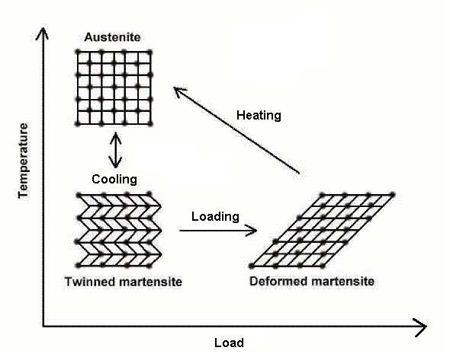

b. Pseudo-elasticity/ Super-elasticity
The phenomenon by which the change in shape occurs in SMA even without change in temperature is called Pseudoelasticity. This takes place at temperature greater than the austenite formation temperature. The load on the SMA is increased and austenite becomes transformed into martensite simply due to loading.
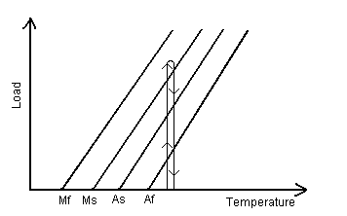
c. Hysteresis
The difference between the transition temperature upon heating and cooling is called hysteresis.
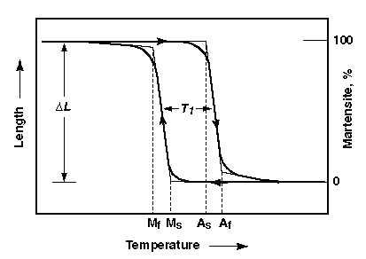

d. SMA’s exhibit changes in electrical resistance, volume and length during transformation with temperature

Applications of SMA
- One of the most common applications of SMAs is Microvalves (Actuators)
- Shape memory alloys are use to make toys and ornamental goods.
- They are used in blood clot filters, artificial hearts and dental applications.
- SMAs are used a thermostat to open and close the valves at required temperature.
Advantages of SMA
- They are very compact in nature
- They are safe and smart
- They are flexible in nature.
- They have non-corrosive nature.
Disadvantages of SMA
- They are expensive (high cost)
- They have low efficiency
- Transformation of shape occurs over a range of temperatures
- Structural arrangements may sometime get deformed

5. Discuss the applications of nano materials in various fields.
Applications of nano materials in various fields
a) Materials technology
- Harder metals having hardness 5 times higher than the normal metals can be produced
- Unusual color paints can be produced
- Smart magnetic fluids are used as vacuum seals, cooling fluids etc.
- Used in nanoelectronics devices such as nanotransistors, ceramic capacitors for energy storage etc.
- ZnO thermistors are used in thermal-protection and current-controlling devices
b) Information technology
- Nanoparticles are used for data storage
- Quantum electronic devices have started replacing bulk conventional devices
- Magnetic devices made of Cu-Fe alloy are used in RAM, READ/WRITE heads and sensors
- Nano dimensioanl photonic crystals are used in chemical/optical computers
c) Biomedicals
- Biosensitive nanoparticles are used for tagging of DNA and DNA chips
- Controlled drug delivery is possible
- Finds applications as an implant material
d) Energy storage
- Useful in magnetic refrigeration
- Metal nanoparticles are very useful in fabrication of ionic batteries
e) Optical devices
- Nanomaterials are used in making efficient semiconductor laser and CD’s
- Nano Zinc Oxide is used to manufacture effective sunscreens
- Used in the coatings for eye glasses to protect from scratch or breakage

6. Explain how nanomaterials are prepared using chemical vapour deposition and pulsed laser deposition techniques.
Preparation of nanomaterials
Top down approach – Bulk materials are broken into nano sized particle
Bottom up approach – Nano materials are produced by building of atom by an atom
Pulsed laser deposition
Principle
The laser pulse of high intensity and energy is used to evaporate carbon from graphite. These evaporated carbon atoms are condensed to from nanotubes.

Construction
A quartz tube which contains the graphite target is kept inside the high temperature muffle furnace. This quartz tube is filled with argon gas and it is heated to 1473 K. A water cooled copper collector is fitted at the other end of the tube. The target material graphite contains small amount of nickel and cobalt as a catalyst to nucleate the formation of nanotubes.
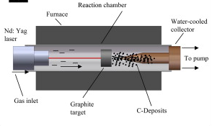

Working
When an intense pulse of laser beam is incident on the target, it evaporates the carbon from the graphite. The evaporated carbon atoms are swept from the higher temperature, argon gas to the colder collector. When the carbon atoms reach the colder copper collector they condense into nanotubes.

Chemical vapour deposition
The deposition of nano films from gaseous phase by chemical reaction on high temperature is known as chemical vapour deposition. This method is used to prepare nanopowder.
In this technique, initially the material is heated to gaseous state and then it is deposited on a solid surface under vacuum condition to form nanopowder by chemical reaction with the substrate. It involves the flow of a gas with diffused reactants over a hot substrate surface. The gas that carriers the reactants is called the carrier gas. While the gas flows over the hot solid surface, the heat energy increases chemical reactions of the reactants that form film during and after the reactions.
The byproduct of the chemical reactions is then removed. The thin film of desired composition can thus be formed over the surface of the substrate.

7. Explain the origin of nonlinear optics. How are second harmonic waves generated?
The field of study concerned with the interaction of light radiation and matter in which the matter responds in a non linear manner to the incident radiation fields is called non linear optics. This behavior is known as non linear effect and the materials which exhibit this effect are called non linear materials.

Second harmonic generation
In a linear medium, polarization (P) is directly proportional to electric field (E)
where - permittivity of free space,
χ - electrical susceptibility.
In nonlinear medium for higher fields, the nonlinear effects are observed.
(1)
Where χ₁ is the linear susceptibility and χ₂ , χ₃ etc are higher order nonlinear susceptibilities.

The electric field passing through the medium with amplitude E₀ is
(2)

Substituting the value of (2) in (1) we have
(3)

We know that
(4)
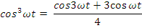

Substituting equation (4) in (3) we have
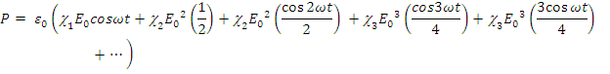
(5)
In the above equation, first term gives rise to dc field across the medium; the second term gives external polarization and is called first or fundamental harmonic polarizability. The third term which oscillates at a frequency 2ω is called second harmonic of polarization and the terms are referred as higher harmonic polarization. Both the first term and third term added together is called optical rectification.
The second harmonic generation is possible only to the crystals lacking inversion symmetry. SHG crystals are quartz, potassium dihydrogen phosphate, ammonium dihydrogen phosphate, barium titanate and lithium iodate.
When the fundamental radiation from Nd:YAG laser is sent through SHG crystal like KDP, conversion takes place to double the frequency i.e. half the wavelength takes place.

8. Explain biomaterials and its modern applications in the field of medicine.
The materials which are used for structural applications in the field of medicine are known as biomaterials. These materials are used to make devices to replace damaged or diseased body parts in human and animal bodies.
Biomaterials should have high compatibility, corrosion resistant and required property. Different materials possess different specific properties.

Classification of biomaterials
i) Metals and alloys are used as biomaterials due to their excellent electrical and thermal conductivity and mechanical properties. The types of biomaterials using metals and alloys are cobalt based alloys, titanium, stainless steel, protosal from cast alloy, conducting metals such as platinum.
Applications
- Stainless steel is the predominant implant alloy. This is mainly due to its ease of fabrication and desirable mechanical properties and corrosion resistant.
- Protosal from cast alloy of Co-Cr-Mo is use to make stem and used for implant help endoprosthesis.
- Ni-Ti shape memory alloy is used in dental arch wires, micro surgical instruments, blood clot filters, guide wires etc.

ii) Ceramics are used as biomaterials due to their high mechanical strength and biocompatibility. Types of bio-ceramic materials include tricalcium phosphate, metal oxides, apatite ceramics, porous ceramics, carbon and alumina.
Applications
- Ceramic implants like alumina with some SiO₂ and alkali metals are used to make femoral head.
- Tricalcium phosphate is used in bone repairs.
- Apatite ceramics are new bio active ceramics. They are regarded as synthetic bone, readily allows bone ingrowth, better than currently used alumina.
- Carbon coatings find wide applications in heart valves, blood vessel grafts, percutaneous devices because of exceptional compatibility with soft tissues and blood.

iii) Bio Polymers
Biopolymers are macromolecules (protein, nucleic acid and polysachacides) formed in nature during the growth cycles of all organisms.

Applications
Biopolymers find variety of applications as biomaterials. The most prominent among them are collagens and its derivatives. Collagens which are major animal structural proteins are widely used in a variety of forms such as solution, gel, fibers, membranes, sponge and tubing for large number of biomedical applications including drug delivery system, vessels, valves corneal prosthesis, wound dressing, cartilage substitute and dental applications.

iv) Composite materials are also used as biomaterials. Sometimes, a single material mentioned above cannot fulfill the complete requirements imposed on specific applications. In such case, combinations of more than one material are required.

Biomaterials in Ophthalmology
Biomaterials are used to improve and maintain vision. Eye implants are used to restore functionality of cornea, lens etc. when they are damaged or diseased. The biomaterials include viscoelastic solutions intraocular lenses, contact lenses, eye shields, artificial tears, vitreous replacements, correction of corneal curvature.

Dental materials
Polymers, composites, ceramic materials and metal alloys are four main groups of materials used for dental applications. A large number of materials are tested for porous dental implants which includes stainless steel, Co-Cr-Mo alloy, PMMA, proplast and Daceon, velour coated metallic implants, porous calcium aluminate single crystal alumina, bioglass, vitreous and pyrolytic carbons. The dental applications include impressions materials, dentine base and ceorons, bridges, inlays and repair of cavities, artificial teeth, repair of alveolar bone, support for mandible.

